Lecture 11



We can combine capacitors in the electric circuits

The equivalent capacitance can be computed

We use circuit diagrams to represent electric circuits

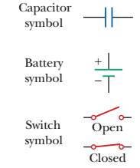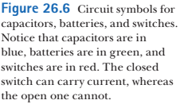



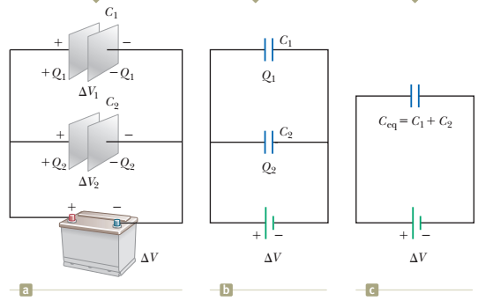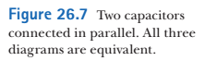

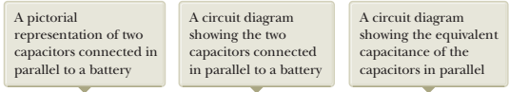

the individual potential differences across capacitors connected in parallel are the same and are equal to the potential difference applied across the combination.



where ΔV is the battery terminal voltage

Capacitors get charges Q1 and Q2



total charge Qtot = Q1 + Q2



We want to replace these two capacitors by one *equivalent capacitor* having a capacitance *C*eq as in Figure 26.7c

the equivalent capacitor must store charge Qtot when connected to the battery

Potential difference ΔV is the same (battery voltage). Hence,



substituting to Eq. 26.7:

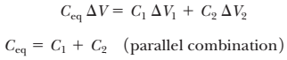

In general,





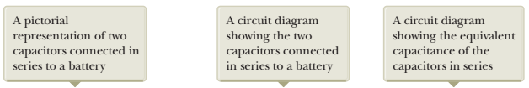

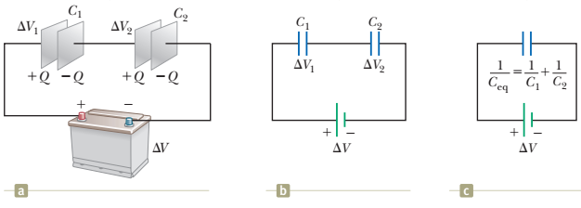



In Figure 26.8 a) a series combination of capacitors is shown

When the battery is connected, electrons are transferred  
out of the left plate of *C* 1 and into the right plate of *C* 2

net charge between capacitors (the right plate C1 and left plate C2) is zero

+Q -----| |----------| |---- -Q

-Q +Q

the charges on capacitors connected in series are the same:



voltage on C1 and voltage on C2 combined should be equal to the battery voltage



Now, can we find a capacitor that is equivalent to the combination of C1 and C2 ? It must have a charge Q

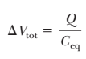





For an arbitrary number of capacitors,



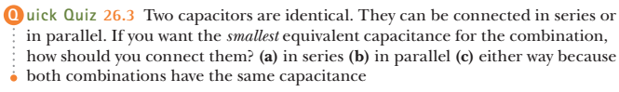

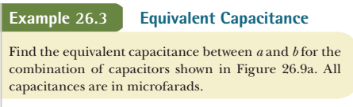

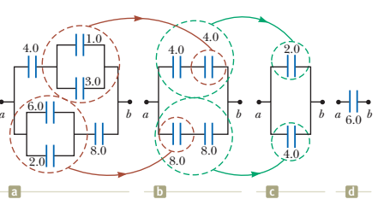

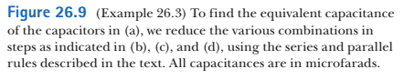

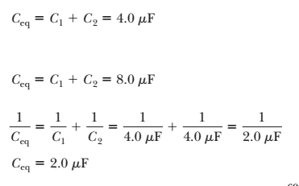

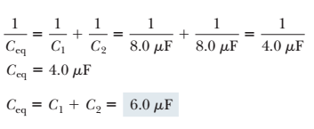



How a capacitor becomes charged:

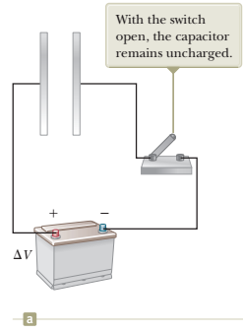 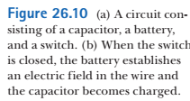

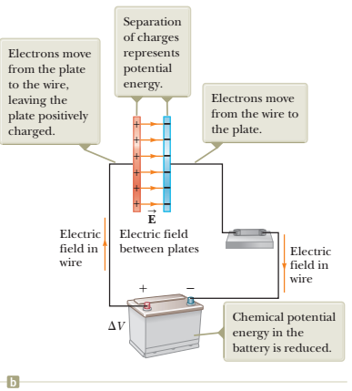

chemical energy of the battery -🡪 electrical energy of a capacitor

How much energy is stored in a charged capacitor ?

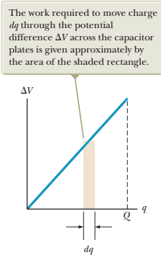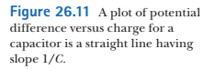

Charge q, V = q/C

TO transfer a small charge dq, dW work is required:



The total work required to charge the capacitor from *q* = 0 to some final charge *q* = *Q* is:



The work done in charging the capacitor appears as electric potential energy *UE* stored in the capacitor.



For a parallel-plate capacitor,





therefore,



the volume of the capacitor: Ad

energy density = U/Ad =



It is a general expression for electric field energy density

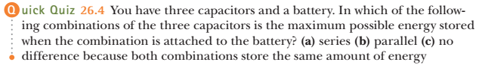

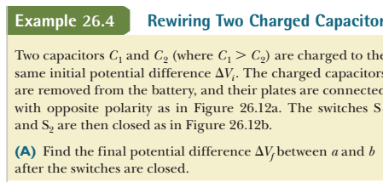

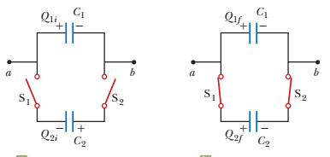

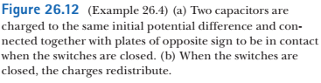

Before the switches are closed, the total charge on the left-hand plates will be:



After switches are closed:



Q1f and Q2f are such that potential differences are the same for both

Qi should be equal to Qf (plates are isolated)

Hence,



**(B)** Find the total energy stored in the capacitors before and after the switches are closed and determine the ratio of the final energy to the initial energy.





we substitute ΔVf into expression above:

 finally,



Energy decreases because electromagnetic waves are radiated before the system comes to equilibrium